Accent

📘 Definition
# Source: AI Source: Provided by: [Data Path: Persons Table -> ID Column: 1, Name_En Column: Motasem Essam] -> From: [ChatGPT] on [5/2/2026]
An Accent is a small area or detail in a design or image that stands out more than the rest. It is used to draw attention or make something visually interesting.

🎨 Accent in graphics and design
# Source: AI Source: Provided by: [Data Path: Persons Table -> ID Column: 1, Name_En Column: Motasem Essam] -> From: [ChatGPT] on [5/2/2026]
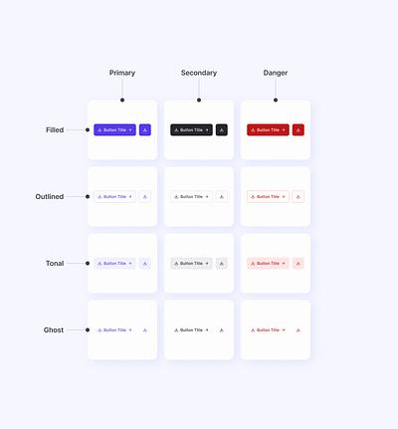
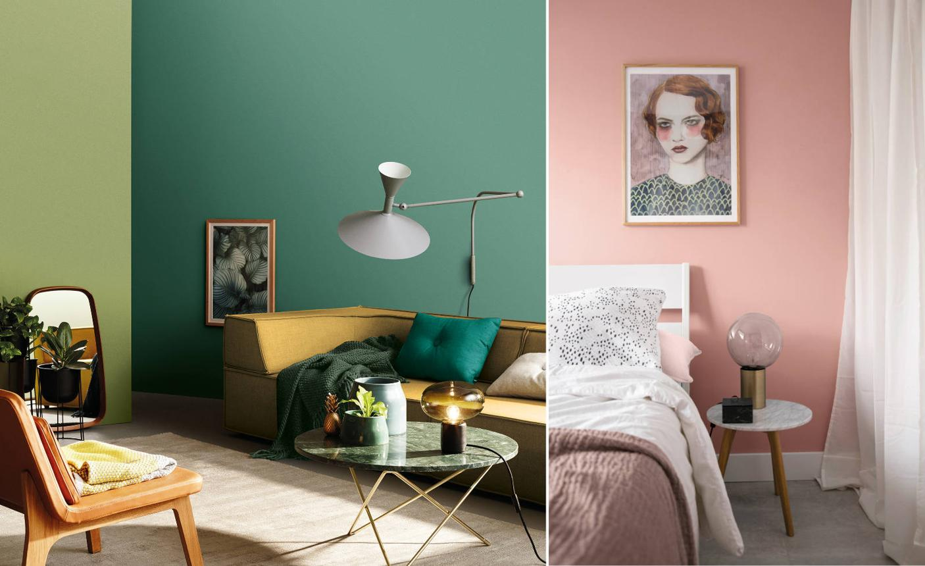
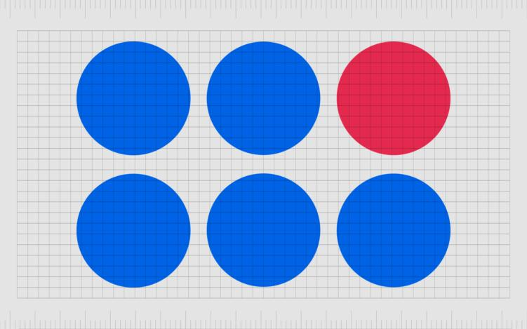
- A bright color in a mostly plain design
- A highlighted button on a website
- A different-colored wall in a room
- A small detail that “catches the eye”

🧠 Simple example
# Source: AI Source: Provided by: [Data Path: Persons Table -> ID Column: 1, Name_En Column: Motasem Essam] -> From: [ChatGPT] on [5/2/2026]
Think of:
- A mostly white website with a red “Buy Now” button → the red button is the accent
- A gray room with a blue wall → the blue wall is the accent

🎯 Purpose of an accent
# Source: AI Source: Provided by: [Data Path: Persons Table -> ID Column: 1, Name_En Column: Motasem Essam] -> From: [ChatGPT] on [5/2/2026]
- 🔍 Attract attention
- 🎨 Improve visual interest
- 🧭 Guide the viewer’s focus
- 💡 Highlight important elements

🧑‍💻 Where accents are used
# Source: AI Source: Provided by: [Data Path: Persons Table -> ID Column: 1, Name_En Column: Motasem Essam] -> From: [ChatGPT] on [5/2/2026]
- 🌐 Web and UI design (buttons, icons)
- 🏠 Interior design (feature walls, decor)
- 🎨 Graphic design (posters, layouts)
- 📱 App design (highlighted actions)

🚀 In short:
# Source: AI Source: Provided by: [Data Path: Persons Table -> ID Column: 1, Name_En Column: Motasem Essam] -> From: [ChatGPT] on [5/2/2026]
Accent = a design element (color or detail) that stands out to attract attention and highlight important parts.

